HELLENIC REPUBLIC
MINISTRY OF ECONOMY & DEVELOPMENT

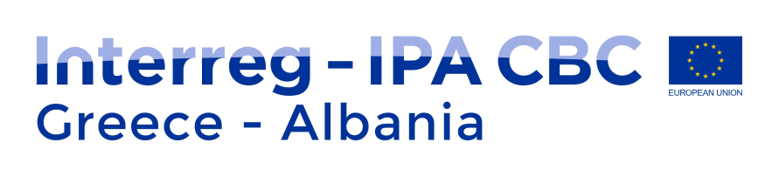

INTERREG IPA CROSS-BORDER COOPERATION PROGRAMME
“GREECE – ALBANIA 2014 – 2020”

PARTNERSHIP DECLARATION

The beneficiaries listed below, within the principles laid down by the Interreg IPA Cross-border Cooperation Programme “Greece – Albania 2014 – 2020”, approved by the European Commission – Decision C(2015) 5482 final of 30th July 2015, as amended and in force.

taking into consideration,
- The EU Regulations, and in particular:
- Regulation (EU) No.231/2014 of the European Parliament and of the Council of March 11, 2014 establishing an Instrument for Pre-Accession Assistance (IPA II)
- Commission Regulation (EC) No.447/2014 on the specific rules for implementing Regulation (EU) No.231/2014 of the European Parliament and of the Council establishing an Instrument for Pre-accession Assistance (IPA II)
- EC approval Decision C(2015) 5482 final of 30th July 2015 of the Interreg IPA Cross-border Programme “Greece - Albania 2014-2020” as amended and in force
- The Community and National Rules related to the:
- public procurement & competition;
- sustainable development;
- protection of the environment;
- equal opportunities;
- non discrimination;
- equality between men and women;
- Τhe 4th Targeted Call for Project proposals of the Interreg IPA Cross-border Cooperation Programme “Greece – Albania 2014 – 2020”;
- The Programme and Project Manual as in force.
- Τhe content and objectives of the project titled

__________________________project title_______________________
(Project Acronym)

Have discussed and agree on the following:

The Partnership consists of:

1. Beneficiary __(name)______ that will be the Lead Beneficiary of the project
Beneficiary __(name)_______
Beneficiary __(name)_______
Beneficiary __(name)_______
Beneficiary __(name)_______

- Having carefully read the 4th Call for Project proposals and the Applicant’s Package before the submission of the project application, agree to undertake the respective actions described in the submitted project proposal in detail.
- Will cooperate for the implementation of the project concerned.
- Will contribute by disposing human resources, know-how, infrastructure, equipment, access to information, promotion and publicity and coverage of the eligible costs of the action according to European Union Legislation (Commission Regulations and Directives) and National Legislations.

The agreeing Parties
LB1 (LB)
(Name of the legal representative of the Lead Beneficiary)
(Position)
(Date)
(Signature)
(Official stamp of the Lead Beneficiary)

PB2
(Name of the legal representative of the Project Beneficiary 2)
(Position)
(Date)
(Signature)
(Official stamp of the Project Beneficiary 2)

PB3
(Name of the legal representative of the Project Beneficiary 3)
(Position)
(Date)
(Signature)
(Official stamp of the Project Beneficiary 3)

………

PB8
(Name of the legal representative of the Project Beneficiary 8)
(Position)
(Date)
(Signature)
(Official stamp of the Project Beneficiary 8)

