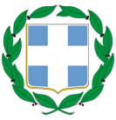
HELLENIC REPUBLIC
MINISTRY OF ECONOMY & DEVELOPMENT

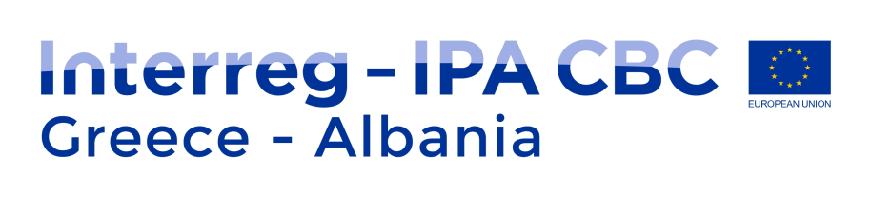
INTERREG IPA CROSS-BORDER COOPERATION PROGRAMME
“GREECE – ALBANIA 2014 – 2020”

CO-FINANCING STATEMENT AND NON-DOUBLE FINANCING

In the case of approval of the project with title “………………………”, applying for financial assistance from the Interreg IPA Cross-border Cooperation Programme “Greece – Albania 2014 – 2020”, we hereby declare that the University of Ioannina / Special Account for Research Funds (Name of Institution) listed as ………………. (LB, PB2, PB3, etc.) in the Application Form, has examined and agreed on his tasks and activities described in the Application Form and will provide …….…… EUR as National counterpart that will amount to 15% of his project budget. We furthermore confirm that any project expenditure related to the above mentioned project has not and neither will be funded by any other EU programme.

The President
Of the Research and Management Committee
of the Special Account for Research Funds
Prof. Spyridon Georgatos
Vice Rector

