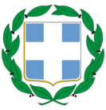
HELLENIC REPUBLIC
MINISTRY OF ECONOMY, DEVELOPMENT & TOURISM

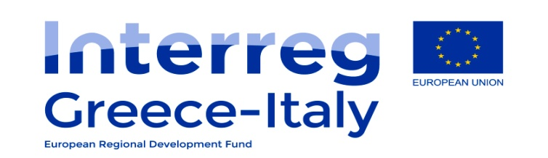

CO-OPERATION PROGRAMME INTERREG V/A
GREECE – ITALY (GR-IT) 2014-2020

CO-FINANCING STATEMENT AND NON-DOUBLE FINANCING

In the case of approval of the project with title “………………………”, applying for financial assistance from the Co-operation Programme Interreg V/A “Greece – Italy 2014 – 2020”, we hereby declare that the University of Ioannina / Research Committee (Name of Institution) listed as ………………. (LB, PB2, PB3, etc.) in the Application Form, has examined and agreed on his tasks and activities described in the Application Form and will provide …….…… EUR as National counterpart that will amount to 15% of his project budget. We furthermore confirm that any project expenditure related to the above mentioned project has not and neither will be funded by any other EU programme.

The legal representative,
Prof. Triantafyllos Almpanis,
Vice-Rector
(Date)

(Signature)
(Official stamp of the Project Beneficiary)

