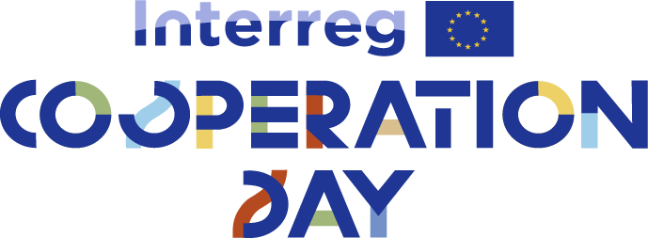
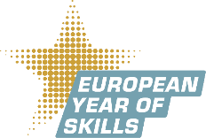
ΔΕΛΤΙΟ ΤΥΠΟΥ

INTERREG COOPERATION DAY 2023- CORFU

The Managing Authorty / Joint Secretariat of Interreg IPA Cross-Border Cooperation Programme “Greece-Albania 2014-2020” are organizing an all day event labelled “Digital Skills for the Citizens”. in the context of “Interreg Cooperation Day” in the island of Corfu on Thursday 19 October 2023.
As this year is labelled European Year of Skills by the European Commission, the MA/JS would like to highlight on projects that have improved the lives of the people of the eligible area by providing or enhancing their sets of skills in various domains.
Given the large amount of projects that contain activities regarding the digitisation of aspects and activities highly relevant to the policies of the Programme, this year’s EC Day aims at highlighting how these platforms can familiarise the local citizens with a digital skillset.
Indicatively, the platforms and applications developed in the context of project such as WASTE RREACT (tool that facilitated the understanding of the separate waste collection), GOAL n ZEBs (e-platform about energy efficiency), iTHEA and THEMA (applications on thematic touristic routes), VIRTUALAND (digitisation platform of cultural artefacts), SMARTiMONY (digital storytelling about monuments of cultural heritage) and TACTICAL TOURISM. In addition, deliverables with outstanding added value that have ben implemented on the island of Corfy will be in display; namely: the demonstration of a digital fruit-fly trap in the context of the project OLIVE CULTURE and a specialised waste collection vehicle in the context of E HORECA WANET).
Last but not least, the recent natural disasters has proven the necessity of projects that deal with prevention and disaster management. In that context, the presentation of the prediction and awareness platform developed by the iAlarms project team will be another important segment of the EC Day 2023.
In the above-mentioned way, a set of best practices of the Programme that is reaching its closure will be showcased.
The event will be a full-day one. In the morning, the participants will be shown around Achilleion Palace and after 16.00 in an open air space at the Ionian University premises (Old mental house – Tsirigoti Sq. 7) the presentations of e-tools developed by the Programme will take place..

