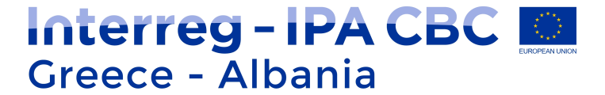

INFO-DAY ON PROJECT IMPLEMENTATION
4th CALL PROJECTS
VENUE: ………………., Korce, Albania
DATE: 26/02/2020
DRAFT AGENDA
9:00 – 9:30 | Arrival of Participants – Registration
9:30 – 9:40 | Official welcome | Ministry for Europe and Foreign Affairs  Managing Authority Unit B2
9:40 – 9:50 | 4th Call State of Play | Joint Secretariat
 | Topics on Project Implementation
09:50 – 10:10 | - Start-up procedures (Milestones, Management team, Procurement Plans, etc.)  - Programme eligibility rules (Preparation and Management Costs, Activities outside Programme area, Staff and O&A costs: options and restrictions) | Joint Secretariat
10:10 – 10:30 | - Lead Partner Principle | Joint Secretariat
10:30 – 10:50 | - Project Modification Procedure | Managing Authority Unit B2
10:50 – 11:15 | - Project Funding for Albanian Beneficiaries | Joint Secretariat
11:15 – 11:30 | - Information & Publicity / Capitalization | Joint Secretariat
11:30 – 12:00 | Q&A
12:00 – 12:30 | Coffee Break
 | Management Information System - MIS
12:30 – 13:30 | - Modification of Application Form  - Progress Report  - Table of Expenditure  - Funding Requests for Greek Beneficiaries | Managing Authority Unit D  Managing Authority Unit C
 | Topics on First Level Control
13:30 – 14:15 | - Eligibility of expenditure | Managing Authority Unit C
 | - Part A - General guidelines - Procedures | Albanian FLC Office
14:15 – 14:45 | Q&A – End of session
15:00 | Light lunch

